# PeopleSafe - Maintenance Choice and Mandatory Fills Allowed and Used

Maintenance Choice and Mandatory Fills Allowed and Used

Related Documents

**Description:** Provides detailed field information (Prescription Details Screen) related to Maintenance Choice and Mandatory Fills in particular to Fills Allowed and Fills Used.

|  |
| --- |
| Maintenance Choice and Mandatory Fills Allowed and Used |

* ** **Maintenance Choice Fills Allowed:** This field displays the number of Retail/Mail Order Fills allowed for a member with Maintenance Choice (MC).
* ** **Maintenance Choice Fills Used:** This field displays the number of Retail/Mail Order Fills a member with Maintenance Choice (MC) has already used as of the date of the claim.

**Note:** This number will NOT update with later fills.

* ** **Mandatory Fills Allowed:** This field displays the number of Retail/Mail Order Fills allowed for a member with Mandatory Mail.
* ** **Mandatory Fills Used:** This field displays the number of Retail/Mail Order Fills a member with Mandatory Mail has already used as of the date of the claim.

**Note:** This number will NOT update with later fills.

Members that have Maintenance Choice or Mandatory Fills, will now display a new field for improved communication as to the number of fills they are allowed versus the number of fills they have received:

** These fields will help determine if a Retail/Mail Order Fill will be rejected for members with Maintenance Choice or Mandatory Mail.

**Examples:**

* If the number indicated in the MC or Mandatory Mail “Fills Allowed” field is greater than the number indicated in the MC or Mandatory Mail “Fills Used” field, then the member has not yet used all the fills allowed per their plan.
* If the number indicated in the MC or Mandatory Mail “Fills Allowed” field is the same as the number indicated in the MC or Mandatory Mail “Fills Used” field, then the next fill will reject since the member has used all the fills allowed per their plan.

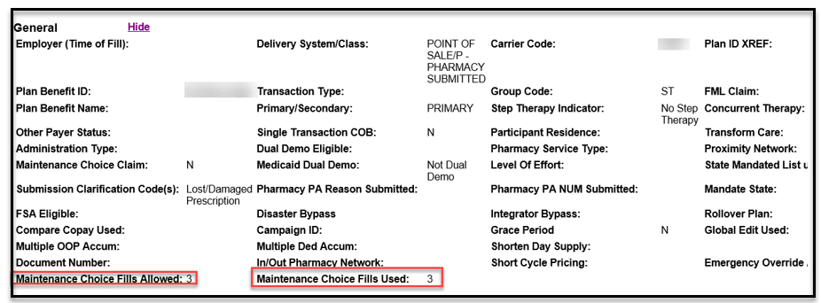

**Prescription Details Screen**

 The numbers shown in the **Maintenance Choice Fills** and **Mandatory Fills** fields are current as of the date of adjudication (i.e., the date of the claim) and will NOT be updated to reflect any fills completed after that date.

**Notes:**

* If the member’s plan does not have Maintenance Choice or Mandatory Mail, then the **Maintenance Choice Fills** and **Mandatory Fills** fields will NOT display.
* Client participation in Maintenance Choice and Mandatory Mail varies. Allowed fills, targeted drugs, therapies, and reset dates vary by plan.
* ** Members with Mandatory Maintenance Choice are limited to a certain number of fills at a Retail/Mail Order pharmacy up to a 30-day supply (day supply may vary per client). After the limit has been reached, the member must receive an 84- to 90-day supply through Maintenance Choice at Mail Service or at least an 84 to 90-day supply at CVS Pharmacy, Costco Pharmacy, Kroger, and several independent pharmacies. If the member continues to fill less than an 84–90-day supplies, they will not be covered by the plan.
* ** Members with Incentivized Maintenance Choice will have increased copays after a certain number of fills up to a 30-day supply (day supply may vary per client) at a retail/Mail Order pharmacy. This provides financial encouragement for the member to participate in the 90-day supply Maintenance Choice opportunity through Mail Service or at a CVS Pharmacy, Costco Pharmacy, Kroger, and several independent pharmacies.
* ** Mandatory Mail is a plan design which requires targeted drug therapies to be filled via mail order benefits for a 90-day supply. While plan provisions may require the use of our mail service, many clients allow a limited number of fills per drug type or class at retail.
* The lookback period of fills on Maintenance Choice medications is 365 days. This may include prior plans and fills, not just the current plan/client the member is with now.
* ** Both Retail and Mail fills will apply to Grace Fill limits.

Top of the Document

|  |
| --- |
| Related Documents |

[Customer Care Abbreviations, Definitions, and Terms Index (017428)](https://thesource.cvshealth.com/nuxeo/thesource/#!/view?docid=c1f1028b-e42c-4b4f-a4cf-cc0b42c91606)

**Parent Document:** [CALL 0049 Customer Care Internal and External Call Handling](https://policy.corp.cvscaremark.com/pnp/faces/DocRenderer?documentId=CALL-0049)

Top of the Document

Not to be Reproduced or Disclosed to Others without Prior Written Approval

**ELECTRONIC DATA = OFFICIAL VERSION / PAPER COPY = INFORMATIONAL ONLY**